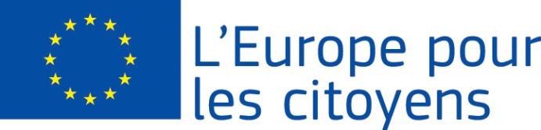
Europe for Citizens

The project «Challenge vs disinfo and Euroscepticism» was funded with the support of the European Union under the Programme « Europe for Citizens»
Strand 2 Measure 2.1 “Town Twinning”
Partecipation: The project was implemented by 120 participants. Fifty-six citizens from Vulcan (Romania) were hosted in San Marzano Sul Sarno (ITALY) for three days to talk about disinformation and European Union.

Venue/Date: the meeting took place in San Marzano Sul Sarno (ITALY) from 23 to 25 September, 2019

Short description:
120 Italian and Romanian participants, for three days in San Marzano sul Sarno (Italy), worked together on:
- Analysis of the context in which fake news are developed;
- Analysis of the target most vulnerable to disinformation;
- How to recognize a "fake news";
- Analysis of the European Commission's consultations on disinformation;
- Collection of opinions and suggestions for actions that the Commission should take to protect the right to correct information for EU citizens.
The cross-border characteristic of the project has allowed to produce a stimulated dialogue built on heterogeneous bases, given the differences in the position of Romanian and Italian citizens towards the EU.
However, the results obtained were achieved thanks to common points of view: the thought that those who denigrate Europe often use fake news.
From here, we recognize the need to increase the perception for citizens of the danger of this phenomenon.
56 Romanian citizens of Vulcan came to San Marzano Sul Sarno (Italy) on September 23, 2019, to implement the project “Challenge vs disinfo and Euroscepticism”.
Three days full of activities aimed at strengthening European integration and identity, and debates on the dangers of fake news and disinformation.
The event lasted three days. The guests left for Vulcan on 25 September 2019.
Thanks to the dissemination of the activities and results achieved, both during the event and after, the project has had an impact on more than 25000 European citizens.
The actuality of the question concerning the spread of misinformation has reached a dangerous level of alert for modern society at all levels.
Participants, speakers and experts pointed out that this phenomenon cannot be managed by individual Member States. Often, those who spread "fake news", even for illicit purposes, live in countries where the acts committed cannot be prosecuted. For this reason, we have found that the shares vs disinfo should be taken at Union level.
The greatest achievement was the citizens' perception of the importance of being part of the European Union. Cooperation between Member States, European citizens and the European Union becomes the only way to protect oneself from giants who manipulate our choices using "fake news" and their dissemination.
The evening of September 23rd after the greetings by the Mayors of the two Cities, the project managers presented project, its aims, the activities of the three days and the "Europe for Citizens" Programme (its aims and objectives).
On the morning of September 24, there was the official twinning Ceremony with a symbolic exchange of the keys of the city, recalling that it was created for the search for peace among peoples; homage to the fallen of the wars; inauguration of a sign, with the words: "MUNICIPALITY OF SAN MARZANO SUL SARNO TWINNED WITH VULCAN (ROMANIA)".
After the official ceremony, there was a discussion on the prepared materials; the exploitation of the results achieved by the EU to counter disinformation. Discussion on what the EU member states and citizens should to make. Relationship between disinformation and euroscepticism.
Show the decision-making process (involvement of States and citizens) of the EU (Action plan vf Disinfo).
On 25 September there were greetings before the departure of the 56 Romanian guests. We have also planned new activities related to the future of our cooperation.

